CloudCME® Create an Account

Instructions for New users to create an account in the CME software system are included below.

Via computer
Step 1: Go to Corewell Health West Michigan Continuing Education.

Click “Sign In” in the upper left corner of the screen.

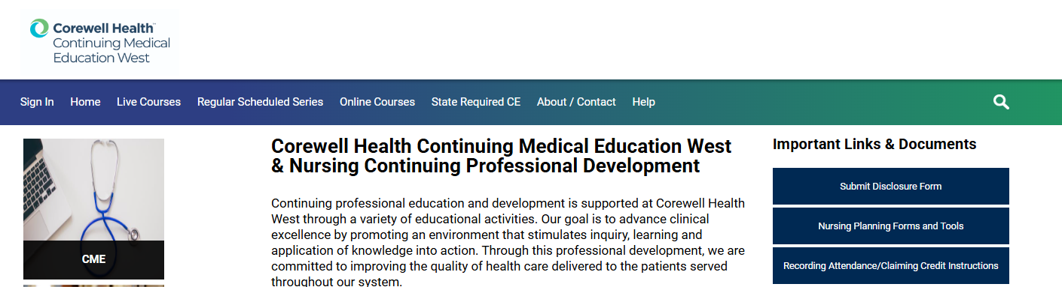

Step 2: Corewell Health employees select “Sign in with your Corewell Health Credentials (Username & Password). You will be automatically signed in if you are on a CWH computer or Wi-Fi network.

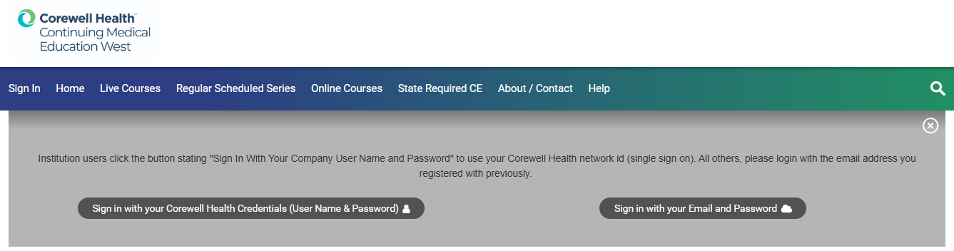

External Users: Select the “sign in with your Email and Password” option and create a new account.

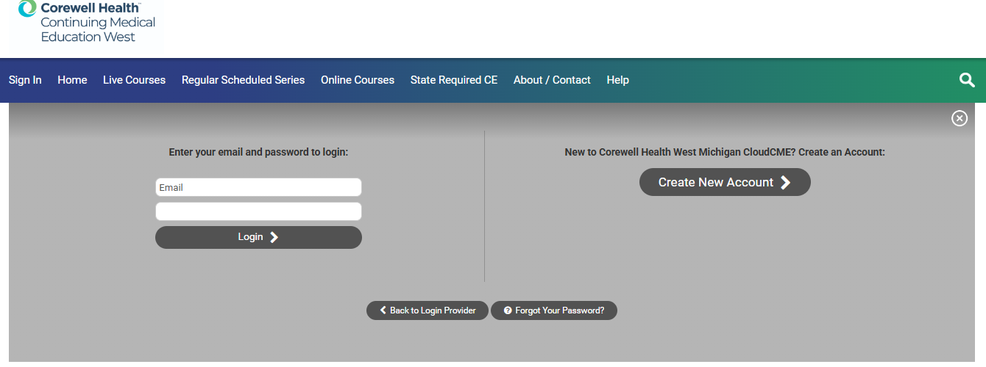

External Users: Complete the required information and and consent to the user agreement.

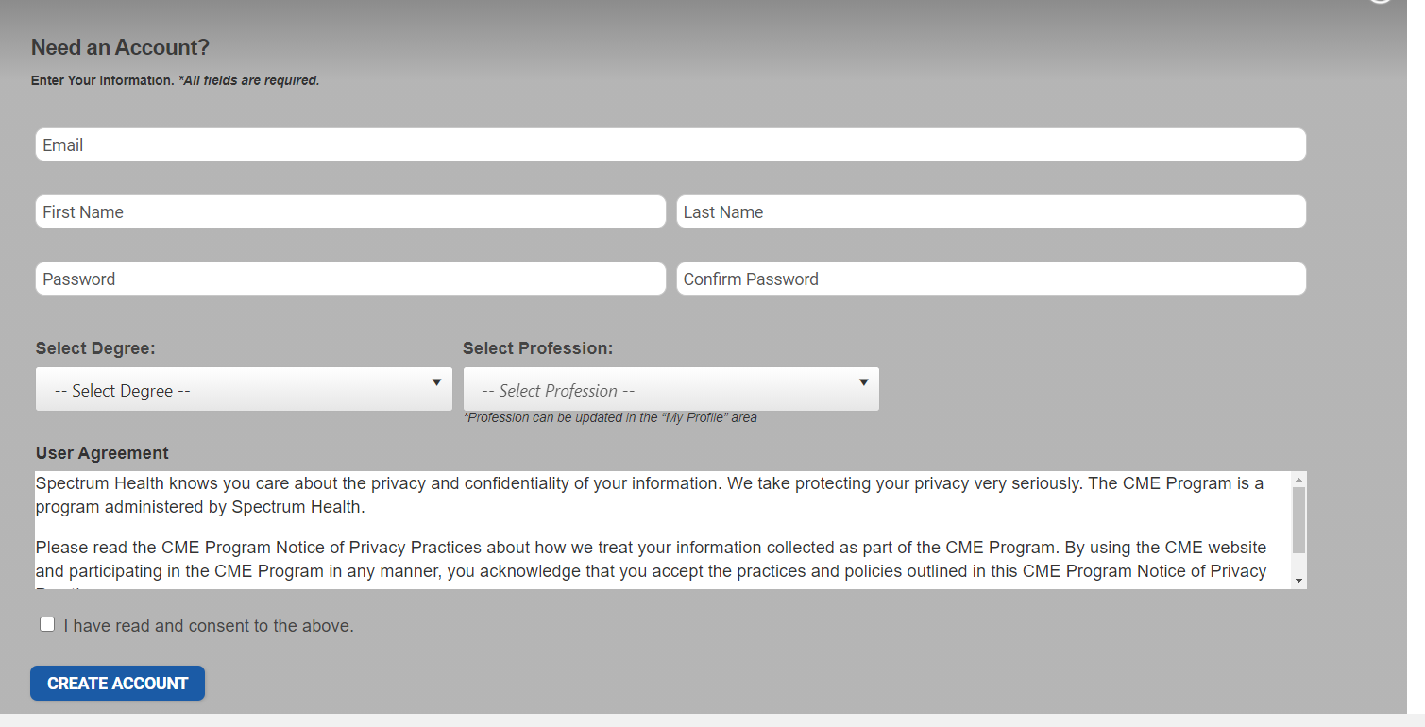

Step 3: Once Logged in, in the upper right corner click My CE and select the Profile tile. Please update additional information in your profile.
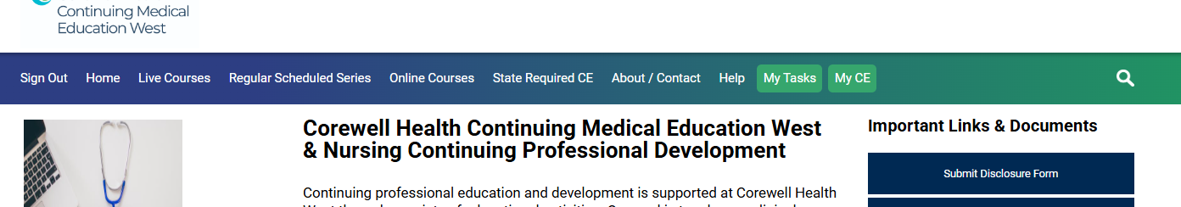
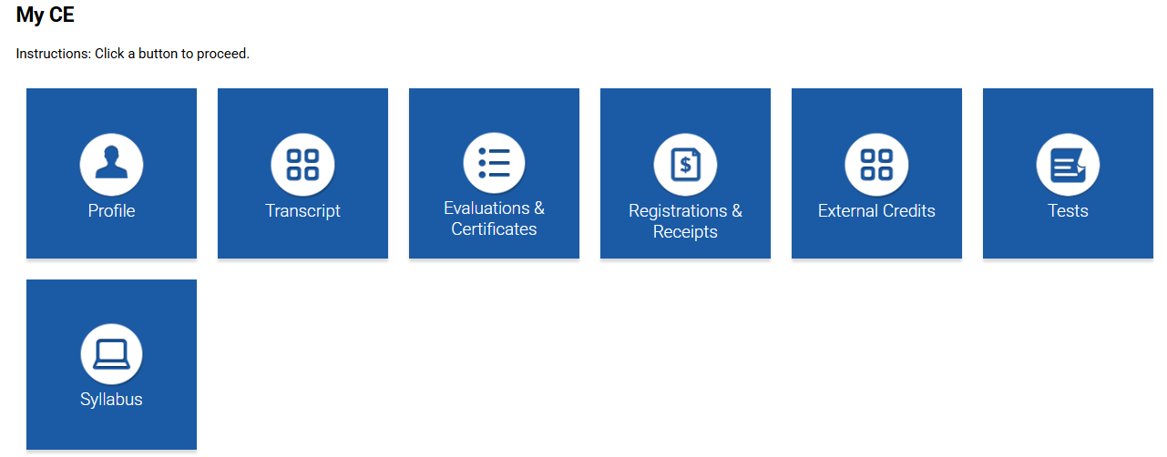
Step 4: Opt-in to the text message attendance program by texting your account email address to: (844) 420-1171. You will receive a text notification indicating your phone number has been updated. Save our CME attendance line phone number for attendance recording. A 5-digit session ID will be provided for each session by the activity coordinator and must be texted in within 12 hours for attendance tracking.

